Find a Ground and post ground availability

This facility allows a club administrator to:

- To post available dates for his own ground(s).
- Mark a ground as booked by another club.
- Search for an available ground within a specified distance

Starting from the Administration Home page, you will see the item ‘Find a’ in the menu list on the left hand side.

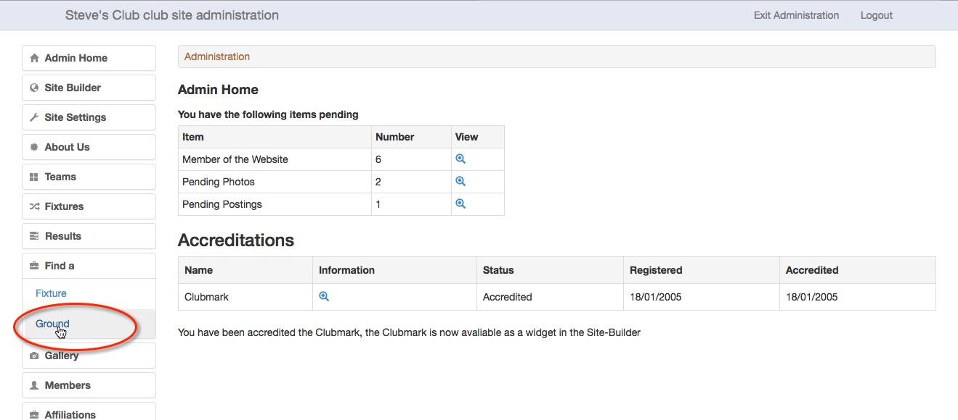

Select Ground to get the screen below. Use the Availability tab to post availability of your grounds for use by other clubs.

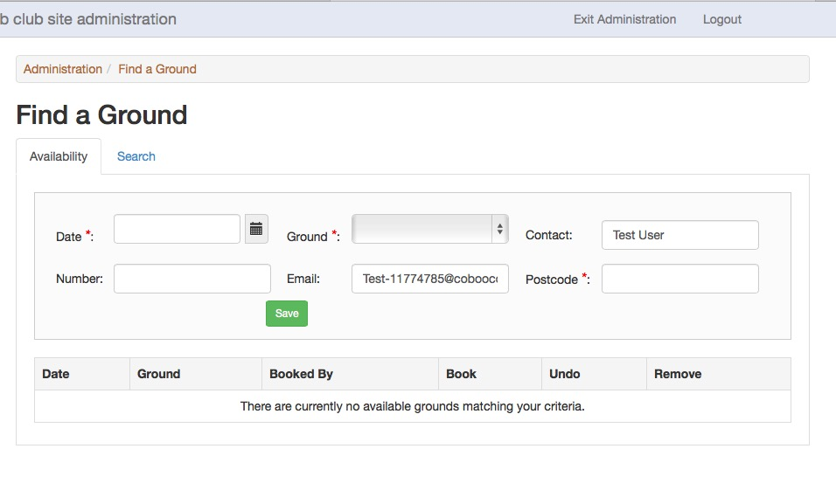

The screen below has been completed with the details as follows:

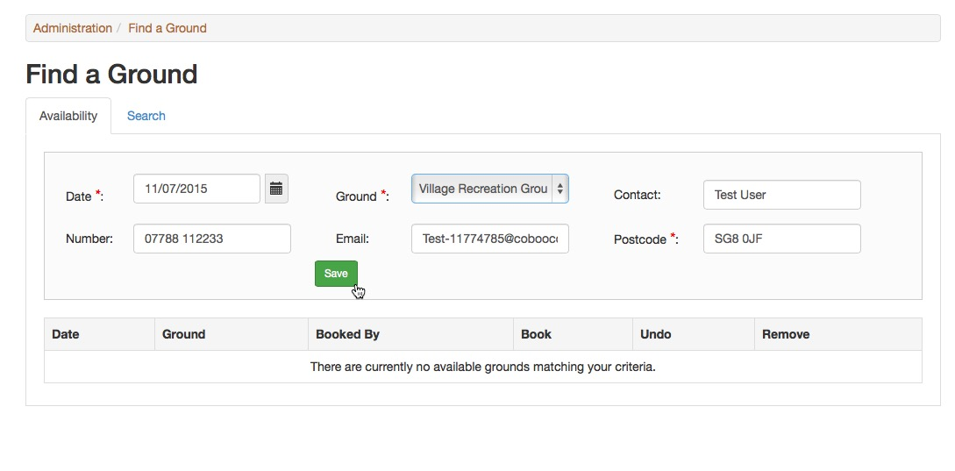

Date*: This is the date on which your ground is available for booking in the format dd/mm/yyyy.

Ground*: Select the appropriate ground from the drop down list.

Contact: The name of the person to be contacted about the booking – defaults to administrator name and may be changed.

Number: The contact number for the person dealing with the booking – defaults to the number for the ground in the Playing Facilities Contact details page and may be changed.

Email: An email address for the person dealing with the booking – defaults to that of the administrator completing the form and may be changed.

Postcode*: The postcode that has been entered in the Playing Facilities Contact details page of your site is used to complete this field. It is required for the calculation of distances. If the postcode is missing, you will get a message asking you to complete this field.
If the playing facility doesn’t have a postcode, use the postcode from the nearest location. Royal Mail’s postcode finder is useful for this http://www.royalmail.com/find-a-postcode

When you have completed the form, click the save button.

You will be taken to back to the Availability screen and the record that you created should appear in the list.

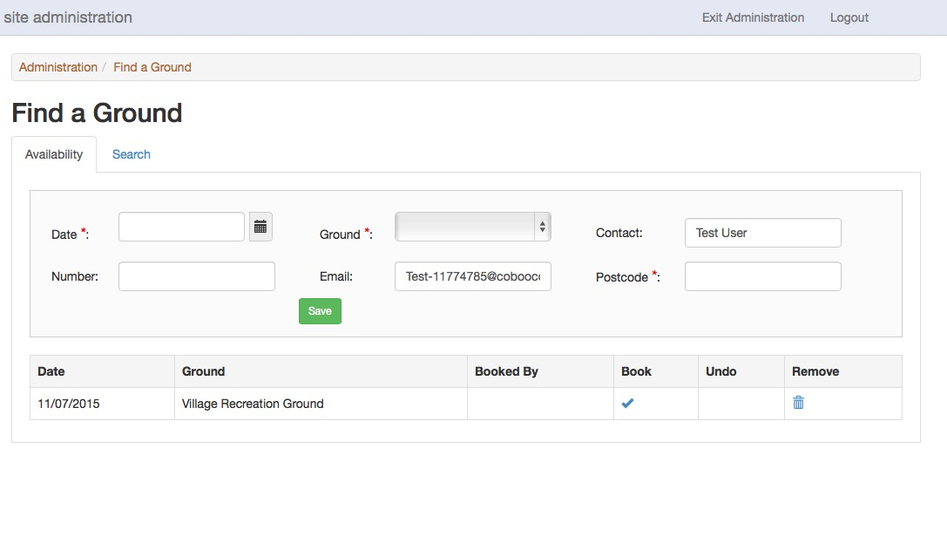
If the ground is no longer available, or you have made a mistake, click on the bin to remove the record and re-enter the details if necessary.

The ground availability will appear on the National Club Cricket Conference site as well as your own. If the NCCC have details of a team wanting to use your ground, the bureau will make contact with you.

To make a booking, NCCC will use the contact details supplied to make arrangements. When you have agreed a booking, click on the tick under ‘Book’ to open a club search as below.

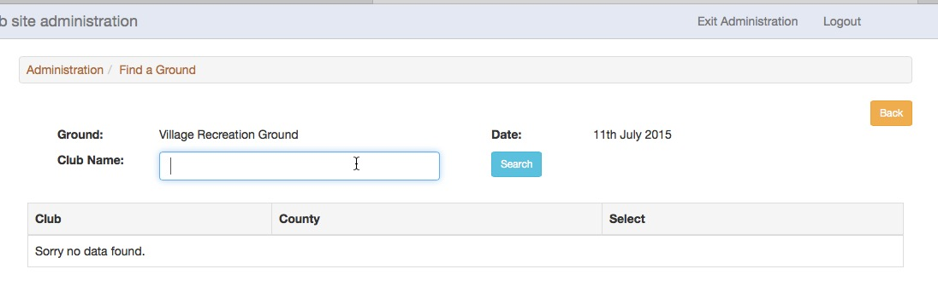

Enter the name of the club that has booked the ground and click Search. The club’s name should appear in the list for you to select by clicking on the tick.

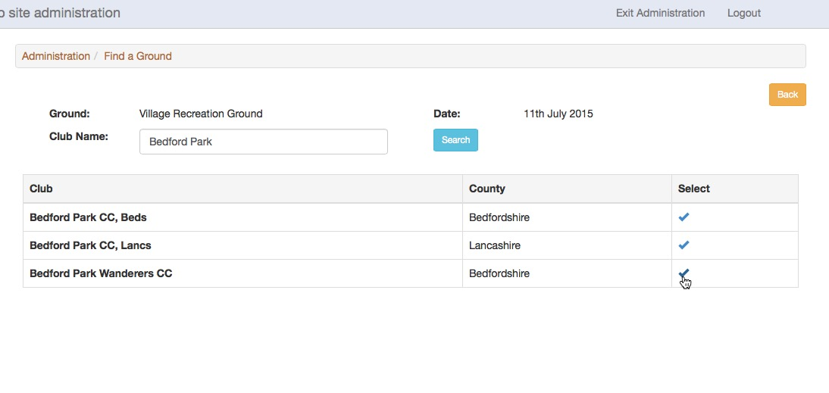

The record is updated to show that the selected club has booked the ground. If the booking is cancelled, or a mistake has been made, click the Undo icon to make the ground available again.

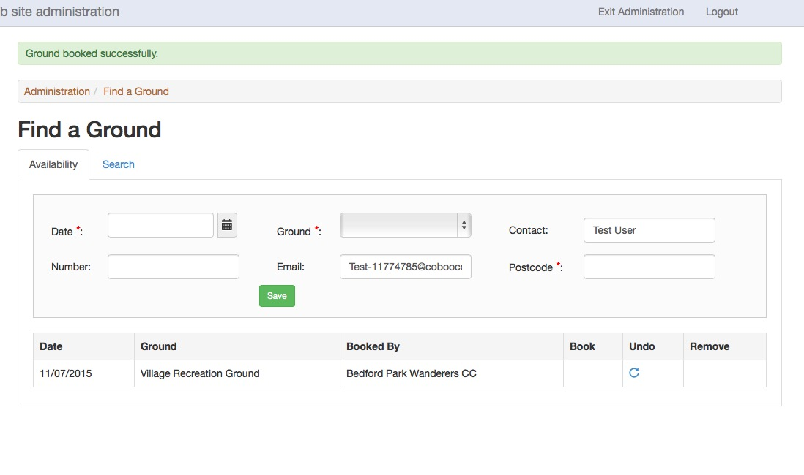

It would be a good idea to update the club’s calendar with the booking since, unlike fixtures, it will not be added automatically.

Search for a ground

Use the Search facility in the Find a Ground section to find available grounds within a specified distance for a selected date.

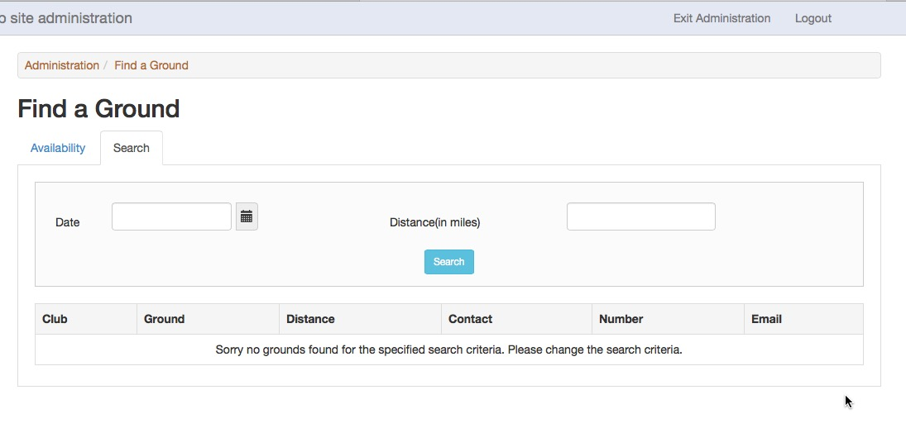

Enter the date and distance that the team is prepared to travel (in miles), and then click Search. The distance is calculated starting from the postcode of the club’s main address in the About Us details, so it’s important not to use your Secretary’s postcode.

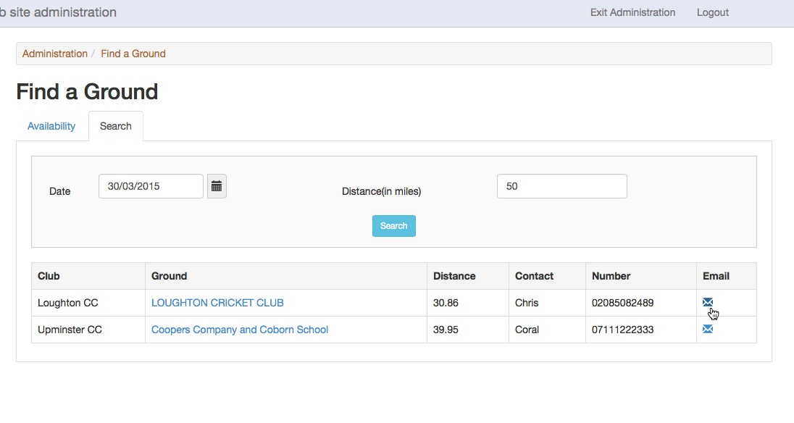
Available grounds matching the search criteria are listed and you should make arrangements using the contact details provided.

