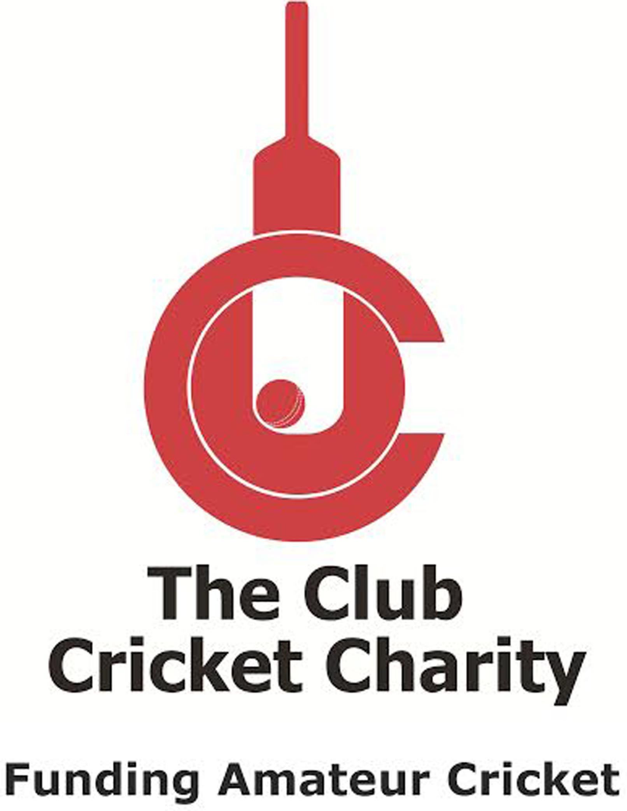
Project Assistance Request
NB: All projects include a full Governance Package, policies and post rescue counselling as standard

Team name: |  | League:
Main contact: |  | Telephone No:
E-mail:
Correspondence Address:
(Please advise if delivery address is different)
Please PRINT as we have to be able to read this!
Post Code
Agreed to by Charity  (CCC use only) | (Charity use only)
Note: | Please note that delivery to you will be via TNT. It is therefore essential we have a clear and accurate address.
The package on offer from the Club Cricket Charity (CCC) in association with the Community Heartbeat Trust charity (CHT) is as follows:
Targeted Project Delivery Date:

……………………….
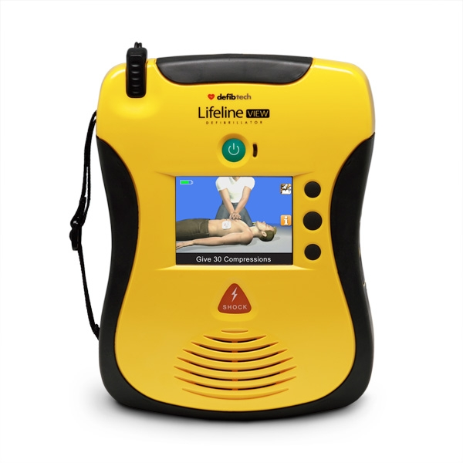  Lifeline VIEW defibrillator |   Optional Familiarisation session |   Managed Solution to include insurances

No other equipment is being offered. The club will be responsible for any consumables such as replacement electrodes and batteries, and these must be acquired via Community Heartbeat for compliance to insurance reasons. CHT retain ownership of the equipment, and will provide theft, damage and public liability insurances.
You will be registered onto the WebNos Governance system and the name above will be the person responsible for the regular checks on the equipment and reporting onto the on-line WebNos system that the checks have been undertaken (unless advise otherwise to CHT).
Your local ambulance service has access to the data on the WebNos Governance system. A list of checks required on the defibrillator will be sent to you with the equipment, along with a booking form for a training session, and also your sign on details for the WebNos Governance system.

Please send completed form by e-mail to the Club Cricket Charity who will confirm acceptance and then forward to CHT.
Or post to

The Club Cricket Charity Name
24-26 High Street
Hampton Hill Signed
Middx TW121PD Date
CHT Office use only

AED Serial Number Pad Expiry Battery Expiry

Node R S W AS SL AW

The Community Heartbeat Trust (“CHT”) Terms and Conditions 2017 CCC

Please note that by working with the CHT Charity you are agreeing to be bound by these terms and conditions (T&C). This is to ensure that the right and correct governance is put in place with respect to your defibrillator, and to ensure the local requirements of the ambulance services are also met.

The CHT has a contract or Memorandum of Understanding (MoU) in place with most ambulance services. By signing these T&C there is normally no need for extra agreements to be in place with the ambulance services.

- Any donation to the CHT must be made prior to the provision of any equipment. Any cheques are to be made payable to The Community Heartbeat Trust.
- CHT may facilitate fund raising for you, and hold monies for you. These will be held in a reserve account specifically for your project only.
- You recognize that the CHT is only responsible for helping donate this equipment to you and any warranties on the equipment are held directly with the manufacturers.
- This is being provided under a CHT Managed Solution, CHT will own the equipment, and be responsible for any insurance.
- If a Managed Solution, the equipment to be used for the scheme will be chosen by CHT, and ownership of the equipment retained by CHT.
- You agree to be responsible for the correct function and maintenance of the equipment supplied, and agree to record any checks, installation details, any out of service notification, and any resupply requests via the CHT WebNos Governance system. CHT will provide you with sign on details for this governance system. Your local ambulance service has access to this governance system.
- Liaison with the ambulance service on registration and activation processes will be undertaken by CHT on your behalf.
- CHT is a charity whose objects include to support the placement of community defibrillators. You waive the right to any claims against CHT.
- Delivery on equipment will be approximately 2-4 weeks
- Delivery will be to your scheme coordinator as advised to CHT on this form.
- You agree to arrange a Community Awareness (Training) programme through CHT for your club, and record the attendees on the WebNos Governance system where possible.
- CHT may also use this location to help advertise the charity, and a mention of CHT must always appear in any of your publicity.
- In the case of activation, it is necessary for the ambulance service to have confidence that the equipment is in a ready state and usable, and to report such incidents and ensure that the equipment is made fully operational after its use. Therefore, you are required to provide as a minimum monthly checks (weekly if possible) on the ready state of the defibrillator, and report this via the WebNos Governance system. Failure to report monthly checks may mean that the local ambulance service will not record the defibrillator site on their Command and Dispatch system (CAD), or may not activate it in an emergency.
- CHT is regulated under the Financial Conduct Authority with Balens Ltd to offer insurance.

