IMMEDIATE

Date: 14th April, 2015
PRESS RELEASE
Cricket Deal Direct and Heather Knight launch new range of cricket gear exclusively for women
England women’s cricket team vice-captain, Heather Knight, has joined equipment retailer and sponsor Cricket Deal Direct and their manufacturing partner SM, in launching a range of cricket gear exclusively for women.
Already a brand ambassador for the innovative, quality equipment manufacturer SM Cricket, this new and exciting venture will further develop Heather’s relationship with the CDD and SM, and will give the batting all-rounder an opportunity to help progress the production of bespoke women’s cricket equipment. 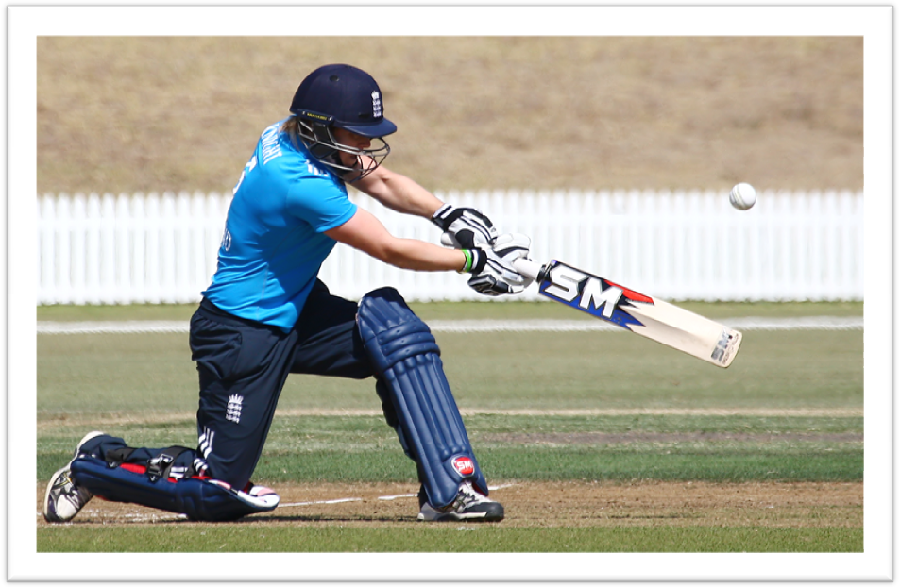
Since her international debut in 2010, Knight has delivered some inspirational performances for England women and has become a superb role model for the sport.
The initial range is being marketed under the brand – Heather Knight Cricket Collection – and includes 4 sub-brands within the collection - HK Exclusive, KH149, HK111 and HK5. These sub-brands include bats, batting leg-guards, batting gloves, kit bags, wicket keeping pads and wicket keeping gloves.

These high quality products have been designed and manufactured exclusively for girls and women by SM, which has extensive knowledge in the manufacturing of women’s cricket gear.

Ian Anderson, Managing Director of Cricket Deal Direct (CDD) said: “We are very excited about this range of women’s cricket gear which Heather has been involved with from the very start. We have a growing presence in the women’s game and the Heather Knight Cricket Collection will allow us to continue our strategy of promoting cricket across all levels and to make quality equipment accessible to all.”
Heather Knight added: “I am delighted to be involved with this project. It is brilliant that CDD and SM are launching an exclusive range of cricket equipment for women and girls, and I am really looking forward to helping with developing the products further.” The new product range is a progressive step forward in Ian’s master plan to build Cricket Deal Direct into a business that is run ‘by cricketers, for cricketers’.
The Heather Knight Cricket Collection was formally launched to the industry on April 13th at The Kia Oval and two further launch events are planned for Finchley Cricket Club on April 17th and Northants Cricket Club in May. The accompanying website is being launched in early May.
Knight recently signed a two year sponsorship deal with Cricket Deal Direct and SM Cricket.
About Heather Knight
Name: Heather Knight
Born: December 26, 1990, Rochdale
County: Berkshire
Test Caps: 4
ODI Caps: 49
T20I Caps: 23
Role: Right-hand bat / right-arm off-spin bowler

England women’s new vice-captain, Heather Knight dominated the 2013 Women’s Ashes to be named player of the series; her magnificent 157 in the Test match at Wormsley was the stand-out innings of the seven-match multi-format series. Primarily an accomplished top-order batsman, last summer also saw her make a significant impact with the ball, having converted to bowling off-spin as the result of a serious hamstring injury at the end of the 2013 Women’s Ashes. She took career-best ODI figures of 4 for 47 and T20I figures of 3 for 10 against New Zealand at the start of 2015.

Knight became a brand ambassador for CDD and the SM brand in 2015, and currently uses the SM US 100 Premium English Willow bat and the hugely popular Players Pride kit. She will now work closely with CDD to develop their women’s range further.

END

About Cricket Deal Direct
Cricket Deal Direct (UK) Ltd was established in 2012 with the objective of sourcing quality hand-crafted cricket equipment direct from local Indian manufacturers and craftsmen. Our goal is very simple – “we want to change the game for buying cricket gear”.
By bringing new and exciting quality cricket brands to the market, we encourage cricket club and sporting associations to link with us and promote these thrilling new products together. Cricket Deal Direct provides a transparent link and reward the organisation for any sales at discounted rates. We also work together with clubs and associations to consider any joint opportunities that can benefit us both, either through sponsorship or other attractive reward schemes.
Quite simply, the company is based around the concept of “helping and supporting” cricket at all levels, including the promotion of Junior and Women’s cricket.
Cricket Deal Direct (UK) Ltd has UK and European distribution rights for the SM cricket brand. SM is located in Meerut, Uttar Pradesh, India and has a long and distinguished history. The origins of the company can be traced back to Sialkot (now Pakistan) in 1925, by the Grandfather of SM’s owners.
Cricket Deal Direct (UK) Ltd is proud to be associated with a company offering such a rich cricketing history and tradition. Today SM offers an exciting and vibrant range of quality cricket products at very affordable prices. Many International and local cricket players have endorsed the range, and we are promoting and introducing the brand throughout the UK and “spreading the word” amongst the cricketing community.
For further information please contact:
Ian Anderson,
Managing Director,
Cricket Deal Direct (UK) Limited
@4CricketDeals
https://www.facebook.com/CricketDealDirect
Tel. +44 (0) 1778 345618
e-mail: ian@cricketdealdirect.co.uk
web: www.cricketdealdirect.co.uk
PR & Media Partners
Olsen Partnership
@OlsenPartners
E-mail: info@olsenpartnership.com
Tel: 0333 101 0075
www.olsenpartnership.com

